**Analysis Report**

**SRN: PES1UG20CS621 Assignment ID: Student Performance_44**

* Scores ranged from **20-120** for math, reading subjects and **24-120** for writing
* Most students scored within **80-120** in Reading subject (Left Skewed)
* In general, both female and male student’s parents have **equal level** of education with majority dropping out after **high school**
* A simple random sample of 100 students chosen from the population has **less sampling error** than a stratified random sample of the same strength
* Majority of the students in the population belong to **Group A and D** races, and this is concluded from the **simple random sample data**.
* **Group D** race has the **highest number** of outliers and students with a grade F (Fail) in all the subjects, closely followed by Group A.
* **Group B and E** races contain the students with **higher grades** in most of the subjects

**Visualization**

* **Scores in ‘Reading’:**

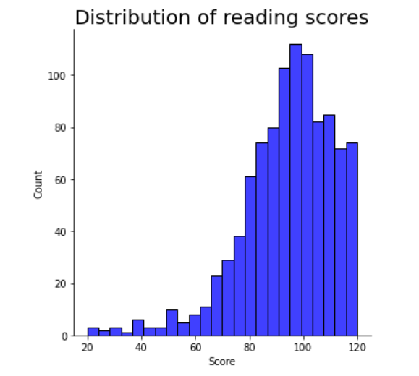

* **Bar chart depicting parental level of education**

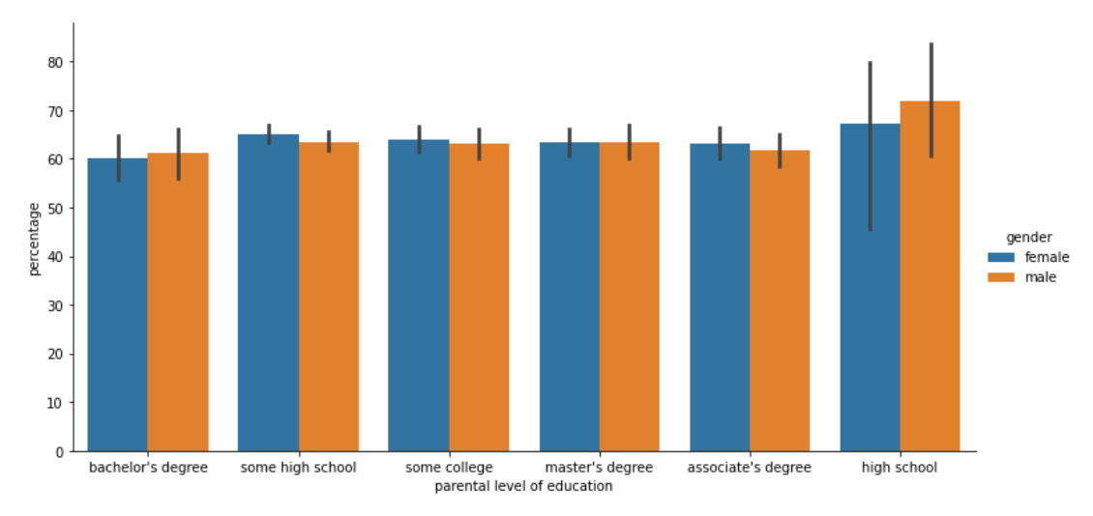

* **Simple Random Sample race distribution:**

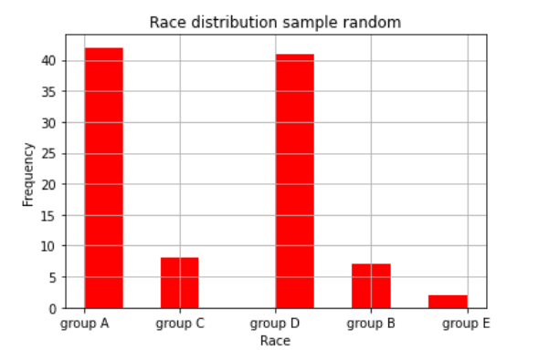

* **Stratified Random Sample race distribution:**

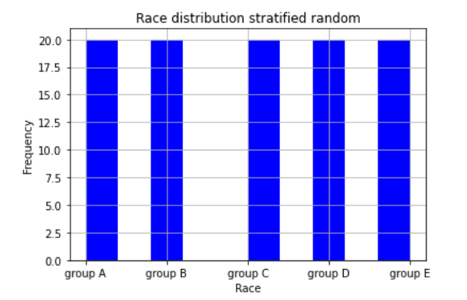

* **Population race distribution:**

